Data Sheet

ECO Drying Cabinets

Features

- Energy savings of up to 65%
- Stainless steel
- Bench mounted
- Adjustable shelf positions

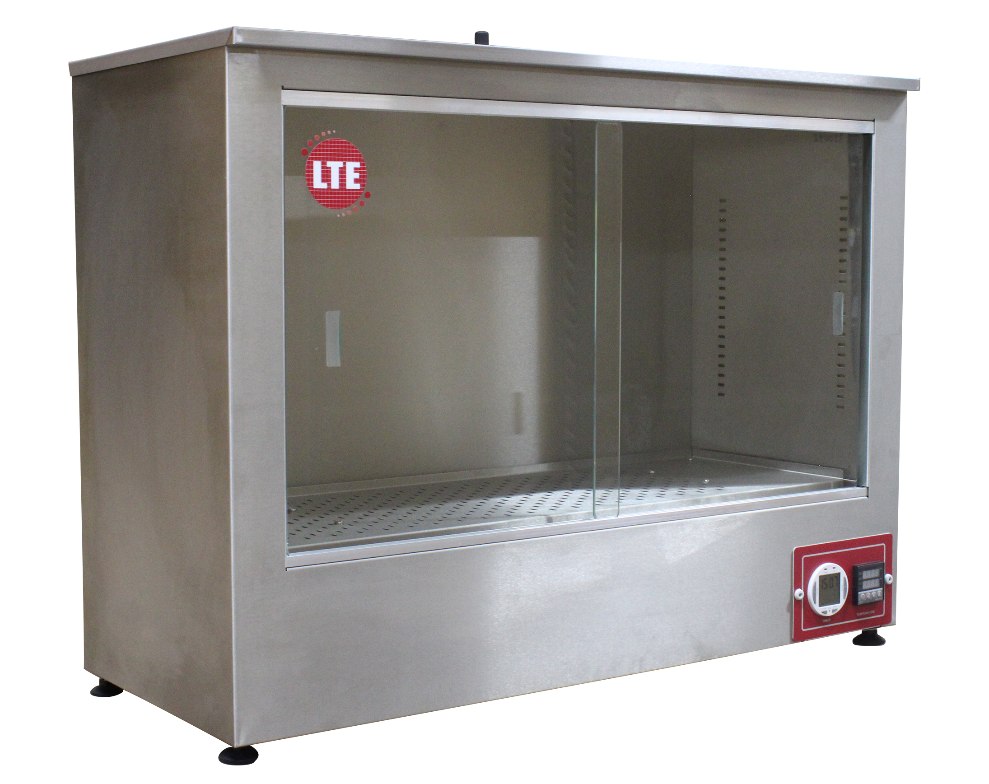

Cat. No. | TD0100SN | TD0180SN
Capacity (litres) | 100 | 180
Air Circulation | Natural Convection | Natural Convection
External finish | Stainless Steel | Stainless Steel
Shelves Included | 2 | 2
Max. Temperature, ˚C | Up to 85 | Up to 85
Internal Dims, HWD mm | 440 x 775 x 300 | 555 x 995 x 325
External Dims, HWD mm | 680 x 900 x 390 | 775 x 1125 x 420

The above is the standard specification. Any modification/deviation for the above will be clearly identified on the quotation front sheet

